# ABSTRACT

We are introducing MEDFORCURE, the android application which is an online pharmacy. This is an internet pharmacy that operates over the internet and sends order to customers. MEDFORCURE is an interactive e-commerce solution which provide users an opportunity to purchase medicines. The main objective for developing this application is to supply the medicines all over the country with just a single click and to reduce the time consumption. Online pharmacy is a web-based application. The customer can post requirement for medicine. The user can purchase medicine online. Medicine is provided at their doorstep by the nearest associate store. As per the prescription, the user can search for the medicine and useful information. This application provides user login to the customer. And admin can get all information regarding expired medicines and orders by users.

# TABLE OF CONTENT

**CHAPTERS - Page Number**

**Candidate’s Declaration** - 2

**Acknowledgement** - 3

**Abstract** - 4

**Table of Content** – 5 to 7

**Chapter 1 – Introduction** – 8 to 10

* 1. Different types of Online Pharmacies -8
  2. Benefits of Internet Pharmacies - 9
  3. Loopholes in Internet Pharmacies - 10
  4. Existing System - 10
  5. Proposed System - 10

**Chapter 2 –Project Description** – 11 to 12

2.1 Purpose of the Project - 11

2.2 Problem Statement - 11

2.3 Special Features - 12

**Chapter 3 –Tools and Technologies** - 13

3.1 Software Used for this Project - 13

3.2 Hardware Requirements for the Project - 13

**Chapter 4 - Implementation Modules and Screen Shots** – 14 to

4.1 Splash Screen - 14

4.2 Sign-In and Sign-Up Page – 15 to 21

4.2.1 Sign-In Page 15 to 16

4.2.2 Sign Up Page - 17

4.2.3 Forgot Password – 18 to20

4.2.4 Recovery Mail – 21

4.3 Home Screen – 22 to 23

4.4 Menu 24 to 37

4.4.1 Med for Cure - 26

4.4.1.1 Strip Ad Banner – 26 to 27

4.4.1.2 Banner Slider Layout – 27

4.4.1.3 Sliding Model Layout – 27 to 28

4.4.1.4 Grid Product Layout – 29

4.4.2 My Orders – 30 to 31

4.4.3 My Rewards - 32

4.4.4 My Cart - 33

4.4.5 My Wishlist - 34

4.4.6 My Account – 35 to 36

4.4.7 Sign Out - 37

4.5 Product Details Activity - 38

4.6 Ordering the product – 39 to 41

4.6.1 Ordering the product through Cash On Delivery method – 40 to 41

4.7 Add or change address of the user- 41 to 42

4.8 Scraping the data from the web – 43 to 44

**Chapter 5 – Conclusion** - 45

**Bibliography and References - 46**

**List of Figures**

Fig 4.1: Splash Screen – 14

Fig 4.2.1 Sign in Page - 16

Fig 4.2.2 Sign Up Page - 17

Fig 4.2.3.1 represents the forgot password screen which is displayed to the user after clicking Forgot Password? Text View on the login Screen - 18

Fig 4.2.3.2 : When user enters his correct email which is registered with us and then presses submit button. A recovery mail gets sent to the entered email id and a success message in green colour is displayed above the button - 19

Fig 4.2.3.3: When user enters an email which is not registered with us. He gets an error for the same in red colour – 19

Fig 4.2.3.4: If user enters a badly formatted email in the edit-text he receives an error in red colour for the same. - 20

Fig 4.2.4.1: Recovery Email - 21

Fig 4.3.1: Icons for categories - 22

Fig 4.3.2 Home Screen of the application - 23

Fig 4.4: Opening the Manu Drawer - 25

Fig 4.4.1: Clicking on Med for Cure - 26

Fig 4.4.1.1 : Strip Ad Banner - 27

Fig 4.4.1.2 : Banner Slider Layout - 27

Fig 4.4.1.3: Working of Sliding Model Layout - 28

Fig 4.4.1.4: Working of Grid Product Layout - 29

Fig 4.4.2: My Orders - 31

Fig 4.4.3 My Rewards - 32

Fig 4.4.4: My Cart - 33

Fig 4.4.5 My Wishlist - 34

Fig 4.4.6 My Account - 36

Fig 4.4.7 Sign Out - 37

Fig 4.5 Product Details Activity - 38

Fig 4.6 Ordering the Product - 39

Fig 4.6.1 Ordering the Product through Cash-on-delivery - 40

Fig 4.7.1 Adding or removing address from delivery activity - 41

Fig 4.7.2 Adding, changing, removing and editing the addresses in My Account - 42

Fig 4.8.1 Explaining our Data Scraping Model - 43

Fig: 4.8.2: BRANDLINKS.csv - 43

Fig 4.8.3: Query we are running in the terminal - 44

Fig 4.8.4: DATA.csv - 44

# Chapter 1- INTRODUCTION

The Internet has evolved into a self-organizing media, which is capable of internal communication. A large number of consumer products including drugs are advertised and sold online. While online drug marketing is the inevitable consequence of a growing economy, it presents unique ethical, legal, and quality challenges - a major factor in becoming an anarchic Internet structure. These challenges are important in the perspective of consumers, doctors and regulators. Among the many commercial activities that are thriving in the area are Internet Pharmacies (Pharmacies, Cyber Pharmacies), which offer a variety of products (eg health and beauty products) and prescription drugs. Some pharmacies only administer the drug with an approved drug, some offer online consultations on prescribing and distributing the drugs, and some dispense the drugs without a prescription. There are many reasons why patients should use the internet when seeking medical care. It works as a second opinion or second doctor for desperate patients. Also, it provides insight into the patient's problems, as well as medication.

**1.1 Different types of Online Pharmacies:**

First, an online pharmacy can be an independent Internet company that does not have a place in a visible pharmacy that a consumer can visit. This first group includes the arm of the pharmacy manager's health programs, which can also provide selected services to non-members. Second, an online pharmacy may be a “click and mortar” pharmacy, usually an online branch of a large pharmacy chain with a storefront. Several chains have bought online companies as a marketing ploy. This partnership has enabled customers to request a drug reapplication through the Websites and has given customers the opportunity to take a local branch pharmacy refill or receive a post-fill. Finally, neighbouring private pharmacies build networks and build independent Websites. Some online pharmacy sites have “cyber doctors,” who diagnose patients online and decide that they should provide medication based on that communication. The management and services of online pharmacies can be fully managed in one region, may pass through many countries, or be located offshore.

**1.2 Benefits of Internet Pharmacies:**

Benefits of online pharmacies Online pharmacies offer many benefits. They are practical and allow customers to avoid issues such as getting out of bad weather, parking, waiting in line, and the inevitable wait for prescription. Patients with limited mobility or those living far from the pharmacy can benefit greatly from official online pharmacies by removing travel to a traditional pharmacy. Potential buyers of online pharmacies are attracted to these sites through major advertising campaigns for pharmaceutical companies in newspapers, through Internet advertisements, including spam, from online pharmacies themselves, and at low prices. It can bring tangible benefits when it comes to saving time and money, but this is not always true. Sometimes medicines are more expensive than regular pharmacies. Online pharmacies have been around the world since the early days of their operation. Online pharmacies have the power to empower patients by providing information on new medicines, side effects, and health conditions. Many Internet pharmacies offer ships at night, allowing customers to avoid delays in regular mail. Another advantage is that some online pharmacies offer lower prices on prescription drugs than those charged by traditional pharmacies. One way to reduce costs is to increase competition. Additionally, many Internet pharmacies have no fixed costs such as rental, maintenance, and property taxes. In addition, Internet pharmacies can provide the secret that is often lacking in traditional pharmacies. Many patients feel uncomfortable asking pharmacist questions in front of other clients. Some Internet pharmacies have a licensed pharmacist available 24 hours a day to answer questions by phone or email. This allows patients to ask questions about their treatment without fear of being heard by their neighbours. The final benefit is that online pharmacies can offer benefits that are not available in traditional pharmacies. Some companies send out email alerts when a drug needs to be re-introduced, such a reminder can improve patient compliance with medication. Improving adherence to treatment not only benefits the physical health of the patient, it is possible the cost of health care paid to insurers, employers, and payers from outside companies can be reduced by improving patient outcomes. Online pharmacies have the potential to promote communication between pharmacists, doctors and patients; whether this can be achieved in this case. For example, the option of sending questions at any time of the day about side effects of medication may encourage patients to ask pharmacists. In addition, the anonymity coverage of the Internet may encourage patients to ask questions about certain medications that they may be too embarrassed to ask at a busy pharmacy.

**1.3 Loopholes in Internet Pharmacies:**

There are two risks associated with self-diagnosis and treatment because consumers can buy prescription drugs without talking to a pharmacist or doctor. In these days of managed care, it can be weeks before a patient can see a doctor for non-emergency purposes. Patients may choose to treat themselves rather than wait for the prescribed time, or the patient may simply be embarrassed to discuss a health problem with his or her doctor. These risks are especially significant given the fact that many Internet pharmacies are unwilling to dispense prescription drugs without prescription drugs. When a patient uses an Internet pharmacy, which provides medication, based on cyber-consultation, or if the pharmacy delivers the drug directly without a prescription, important protections are lost. A patient not only misses a doctor's appointment, it is possible that a licensed pharmacist may not review a prescription. The patient passes two traditional therapists who inform patients about proper use, adverse side effects, and drug interactions. Another return to the Internet pharmacy can be costly, as some consumers pay more for prescription drugs available online. High shipping costs and the inability to participate in many insurance programs add to the costs. Another area of concern involves confirmation of a doctor's appointment. A cyber doctor's qualification and experience may be questionable, yet the patient has no way of examining the doctor. It is possible that a designated physician may leave his or her specialized position; in a non-cyber country, patients would not normally visit an orthopaedist obtain a Viagra prescription.

**1.4 Existing System**

The customer goes to the store to buy the necessary medicine. So much time is spent and one gets tired. If he wants to exchange a product, he goes back to the store and changes one. The whole process depends on physical interaction.

**1.5 Proposed System**

Online Pharmacy is easy to use and easy to order. Customers choose the medication according to their needs and order it with a single click. But before using the app, customers need to create a login account and fill in all the details like name, address, date of birth, email address etc. Customers are able to view the condition of the medication. The business purpose of the application is to provide medicines to all people.

# 2. PROJECT DESCRIPTION

**2.1. Purpose of the project**

The purpose of the application is to provide medicines across the country with a single click and to reduce the use of time. MEDFORCURE is a web-based application. The user can submit medication requirements. The user can buy the drug online. Medicine is provided at their door by a nearby store. Depending on the doctor's prescription, the user can search for medication and useful information. This app provides information on daily use of medications. This application provides user login to the customer.

The online pharmacy system serves many purposes, including the safe and effective dispensing of prescription drugs. The project will help the nation around the world 24/7 and will also help expand and grow the online pharmaceutical and pharmaceutical business.

**2.2. Problem Statement**

First, choosing the right treatment for the type of disease often takes time and makes the patient or client wait.

Second, in drug stock management the pharmacist must inspect it by hand and not send a warning of a drop in medicine to get rid of it. Therefore, this application provides an opportunity to set the process for selecting and alerting the stock market alert system. In the end it is still important, no analysis is being done about the type of medication that is usually bought by clients or patients in the area. This is also important in determining the most needed drugs for clients so that the pharmacist can prepare to order more in that field or type of medicine.

**2.3. Special Features**

* Manage all customer information digitally.
* Protect existing clients and attract new clients.
* Clients can buy medicines from anywhere.
* Special offers for display of generic medicines and high quality products.
* Good user experience.
* Customers can make free chat with us.
* Medication for drug filling will be automatically sent to all our clients.

**3. TOOLS AND TECHNOLOGIES**

**3.1 Software Used for this Project:**

OPERATING SYSTEM: Windows 10

FRONT –END: Xml

LANGUAGE: Java for backend, Python for Web Scraping

DATABASE: Firebase

PROTOTYPING TOOL: Figma

**3.2 Hardware Requirements for the Project:**

PROCESSOR: Intel dual core, i5

RAM: 4GBGB

HARD DISK: 500GB

**Chapter – 4**

**IMPLEMENTATION MODULES AND SCREENSHOTS**

**4.1 Splash Screen**

Splash Screen in an Android application is the first screen visible to the user when the application is launched. It is a very important screen in the application as it is user’s first experience with the application. It needs to be simple, sober and beautiful.  
The splash screen for our application has logo of the application in white colour in the centre and the application’s theme colour in the background.

It is visible to the user for few seconds and then the user sees the login and register screen.

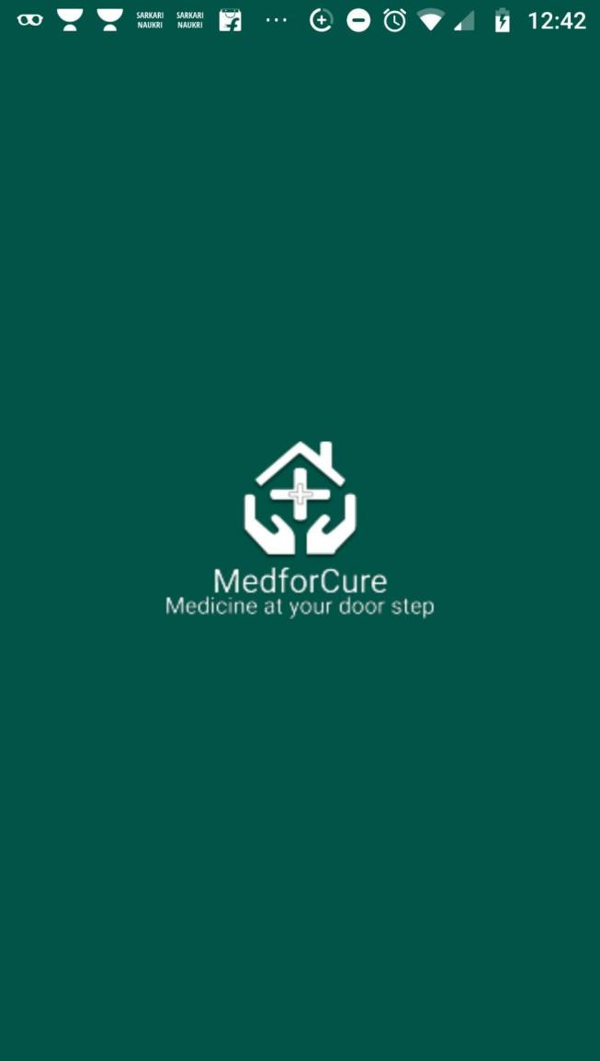

Fig.4.1: Splash Screen

**4.2 Sign in and Sign up page**

After seeing the splash screen for few seconds, the user sees our login page. Like all the login pages, anybody who is already registered with us can log in to the application by his/her email and password.

Our login screen has our app’s logo on the top with a close button on the top-right corner (close button , when pressed, will send the user to the home screen which will enable the user to see our catalogue. User must need to log in the application to buy any medicine.

**4.2.1 Sign in Page:**

The sign in page enables the user the log in the application with his email and password.

After signing in the user will be sent to the home screen to view our catalogue.

**Cross Button:** In case, he presses the cross button, he will be sent to the home screen for just viewing our catalogue. He would not be able to buy any medicine unless he signs in.

**Forgot Password?:** If the user has forgotten his password, then he/she can click on “Forgot Password?” Text view to go the forgot password screen which will then enable the user to reset his password.

**Don’t have an account?** **Sign up!:**  On clicking on this Text view, the user will be sent to our create account page which will enable the user, to register with us.

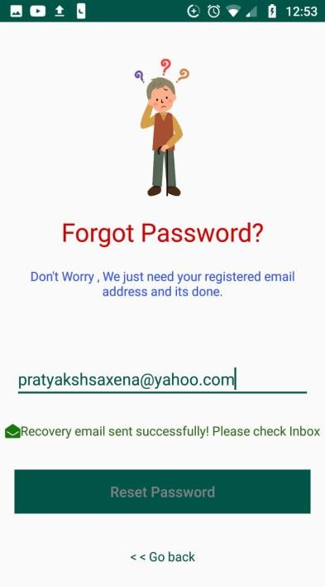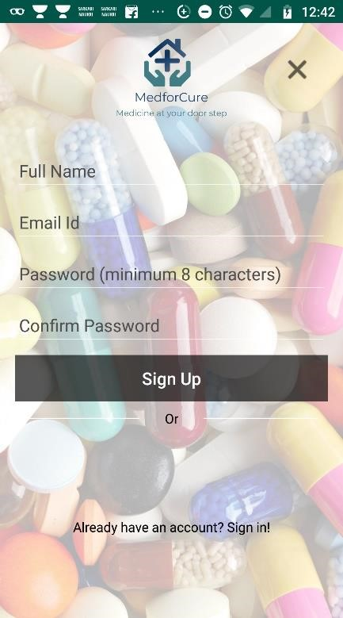

Fig 4.2.1 Sign in Page

Click

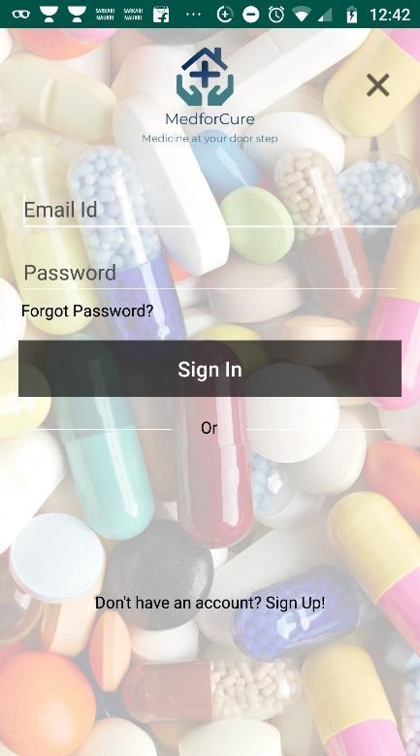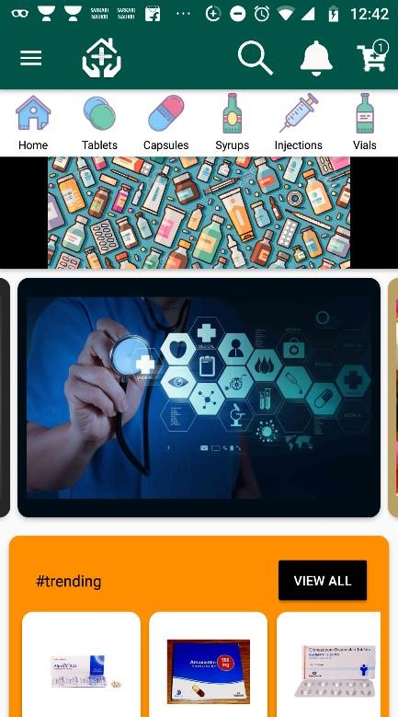

**4.2.2 Sign Up Page:**

This page enables the user to register with us. He/She needs to enter his full name, email id, and password (twice for confirmation) and he will be sent to the home screen of the page and will also get registered with us.

**Cross Button:** In case, he presses the cross button, he will be sent to the home screen for just viewing our catalogue. He would not be able to buy any medicine unless he signs in.

**Already have an account** **Sign in!:**  On clicking on this Text view, the user will be sent to our log in page which will enable the user, to sign in with us.

Click



Fig 4.2.2 Sign Up Page



**4.2.3 Forgot Password:**

This activity lets the user to reset his/her password if the user has forgotten his/her own password.

Our forgot password screen has a picture of confused man cartoon on the top and with four text views (out of which 1 is clickable), one edit text and a button.

In Edit Text, the user needs to enter his email (same email which he has registered with us) and then he needs to press the reset password button. After entering something, in the textbox, the button enables otherwise the button is disabled by default.

If user presses on “<<Go back” text view, then he/she will go back to the login screen.

After, verifying user’s email, a recovery email is sent to the user through his/her email and a successful message will be shown on the screen in **green colour.**

In case, the user enters badly formatted email, or an email which is not registered with us, he will get the respective error in **red colour.**

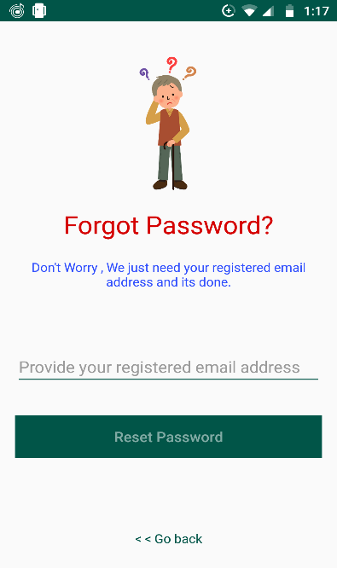

**Fig 4.2.3.1** represents the forgot password screen which is displayed to the user after clicking **Forgot Password?** Text view on the login screen.



**Fig 4.2.3.2** : When user enters his correct email which is registered with us and then presses submit button. A recovery mail gets sent to the entered email id and a success message in green colour is displayed above the button.

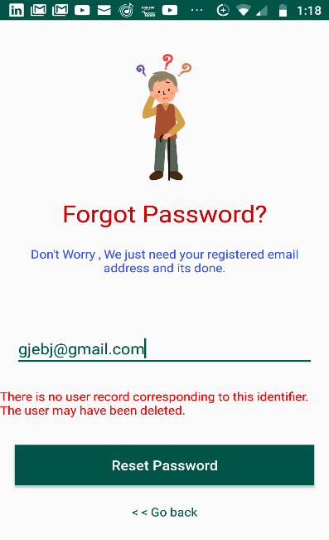

**Fig 4.2.3.3:** When user enters an email which is not registered with us. He gets an error for the same in red colour

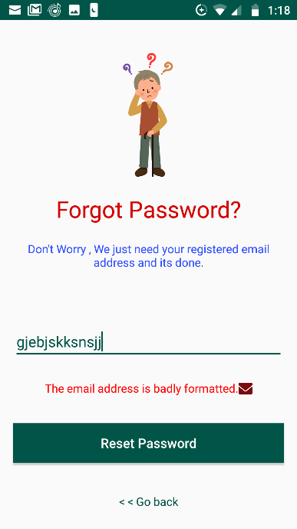

**Fig 4.2.3.4**: If user enters a badly formatted email in the edit-text he receives an error in red colour for the same.

**4.2.4 Recovery Mail**

After clicking the reset password button, in the forgot password activity, a recovery email gets sent to the entered email id of the user and through which the user can reset his/her password.

For recovery email, we have used authentication API of firebase.

If the user clicks on **RESET PASSWORD,** then he is sent to a webpage. In which he has to enter his new password, then press on save button.  
After clicking on the save button, user’s password is changed and then he can login through his new password.

Click

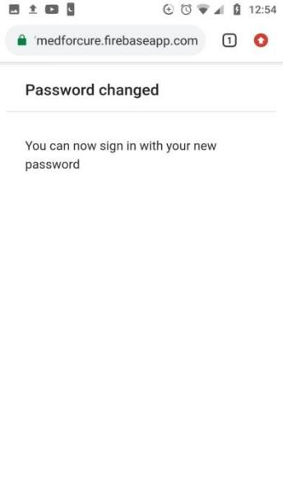

Enter a new password

And click save

Fig 4.2.4.1: Recovery Email

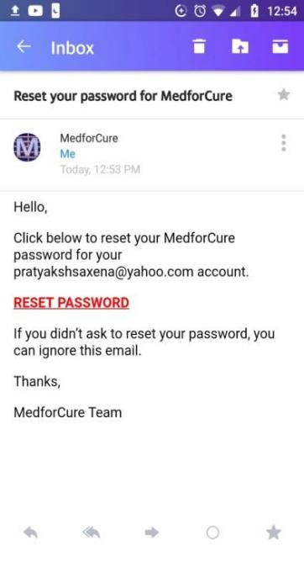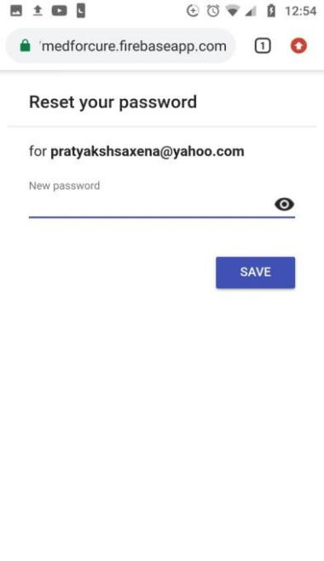

**4.3 Home Screen**

Application’s home screen is the most important part of the application as it shows our catalogue in different designs. It also has banners which can be used to show advertisements for local shops and can also be used to show our customers latest offers.

Our application has a navigation bar at the top which shows the following details:

* Our navigation bar has menu button on the top-left corner which can be clicked to open the menu of the application.
* On the right of the menu button , app’s logo is placed which will make an identity of our company in customer’s mind.
* On the right most corner, Cart button is placed which can be clicked to show items in the cart of the user. A badge is also placed on the cart, which shows number of items in the cart up to 99 and if number of items is greater than 99 then badge shows “99+”.
* On the left of cart icon, a notification bell is placed which will remind user of recent notifications for him.
* On left of notification item, we have search icon, which when clicked, enables the user to search in our catalogue.

The navigation bar gets collapsed when

Below the navigation bar, we have categories slider, which can be slidden to see various categories in our application. If any category is clicked, the user is sent to that categories fragment which will also look like home screen but will have products of only that category

We have currently following categories in our application:

* Tablets
* Capsules
* Syrups
* Injections
* Vials
* Creams
* Drops
* Inhaler
* Spray
* Surgical Items

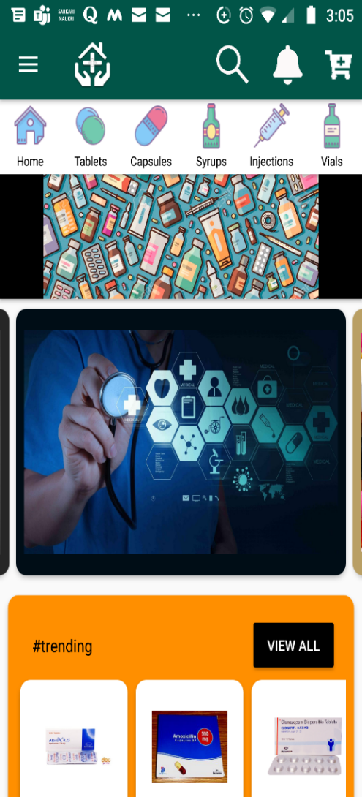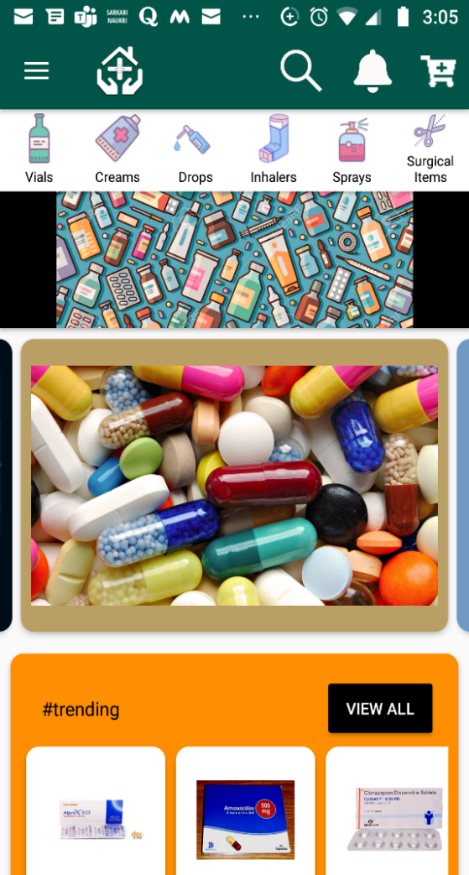

Fig 4.3.1: Icons for categories

Below the categories, we have a strip ad banner which can be used to show advertisements or recent offers.

Below the strip ad banner, we have a sliding banner, which can be slidden to view advertisements and offers.

Below the sliding banner, we have a sliding product catalogue which can slidden upto 8 items. The user can also click on View all button to view the remaining products.

The View All button will not be shown, if the catalogue has less than or equal to 8 items.

Below the sliding product catalogue, we have another strip ad banner which does the same as the previous one.

At the last, we have a grid product layout, which shows our products in a grid which looks very beautiful to the user. On the home screen only 4 items are shown in a grid. The user can click the view all button to show the remaining items in another fragment. The view all button will not be visible, if there are only 4 items for respective catalogue.

Note: The categories, and the sequence of the layouts and banner can be changed from the database and more layouts can be added in the application from the database. We wouldn’t need to give update to the user when we want to add any category or change or add layouts and banners.

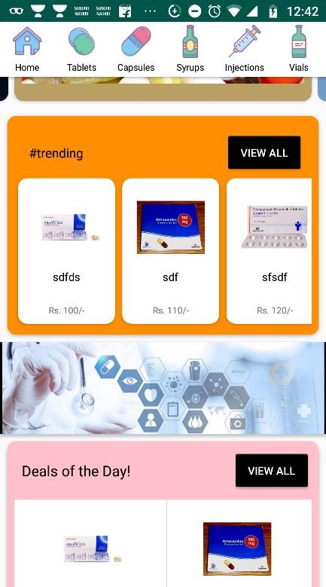

Fig 4.3.2: Home Screen of the application

**4.4 Menu**

Menu is a very important feature in an application. Menu lets the user to explore the application. When the user clicks on the menu button on the top left corner, then the menu of the application opens which has various buttons which can be clicked to go to a different screen.

The menu of our application has currently, 6 buttons which are:

* **Med for Cure**: When this is clicked, the user goes to the home screen of the application
* **My** **Orders**: It can be clicked to view ordered items’ details.
* **My** **Rewards**: It can be clicked to view rewards obtained by the user by purchasing different items. Rewards can be used in future purchases. This feature will increase our sale as people will buy from us by using the rewards which will increase our sales
* **My** **Cart**: This button can be clicked by the user to go the cart and see the items added in his cart. The user can also go to the cart from the button on the navigation bar.
* **My** **Wishlist**: Wishlist consists of the products which user added to it for future purchase.
* **Sign** **Out**: This button will sign the user out the application when clicked.

Menu is visible to the customer at most of the screens of the application. When menu is not visible at any screen, then a back button is visible on the place of menu by clicking on which, user can go back to the previous screen.

Fig 4.4 Opening the Menu Drawer

Click

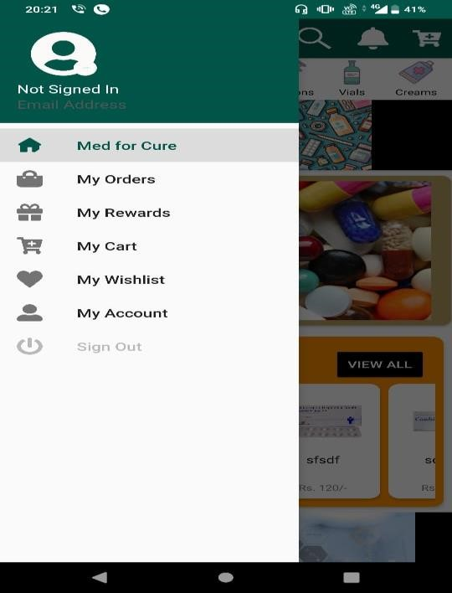

**4.4.1 Med for Cure**

When the user clicks on this button of the menu, then the user is sent to the home screen of the application. Our home screen, its design, is already discussed above. Here, We are going to look into our home screen more closer. We will talk about each element of the home screen deeply.

Fig 4.4.1: Clicking on Med for Cure

Click



**4.4.1.1** **Strip Ad Banner**

This is a very useful feature of our application. Not much for our customers, but surely for us.

We can take advertisement fees from our local medical stores and can advertise their store on our home page through this layout. It will help us in increasing profit for our application. It will also help the medical stores owner to increase their sales through advertising their offers. It will also help the customers to get the medicines at minimal prices. This feature is linked to our database. So we can easily change the banner and also add or remove this layout from the application in just a click.

If the advertisement banner image’s dimensions does not match the dimensions of the layout, then , we can also give background colour for the strip ad banner which will be shown at the edges, if the image does not fit properly inside the layout.

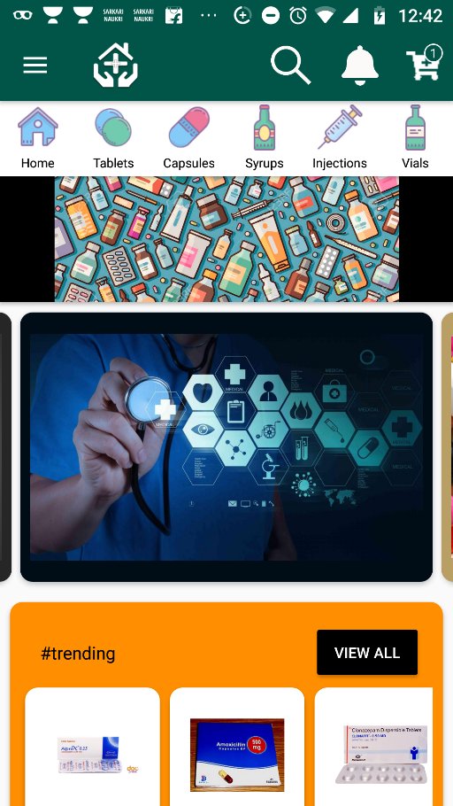 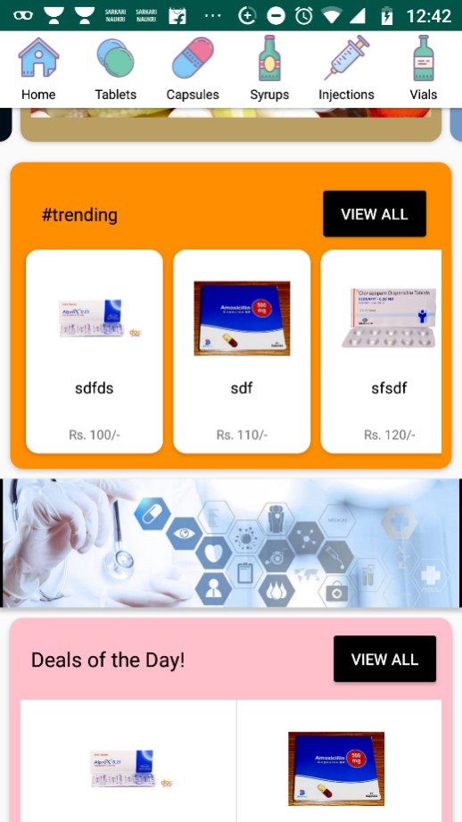

Fig 4.4.1.1 : Strip ad banner

**4.4.1.2 Banner Slider Layout**

This layout consists of set of banners. Each banner can be slidden for viewing the next banner.

The banner also automatically slide itself after 8 seconds which is a great time for the user to have a glimpse of what we want to show them. This layout will be shown to the user for letting them know of our latest offers and rewards.

Each banner also have it’s own background colour if the banner’s dimension’s does not match to the layout’s dimensions. The number of banners, their images and their background colours all are assigned via databases. So, We can easily change the banners, background colours through our database. We can also, change the index of this layout(at which number the layout is shown from the top of the home screen) and can also remove the layout completely through our database.

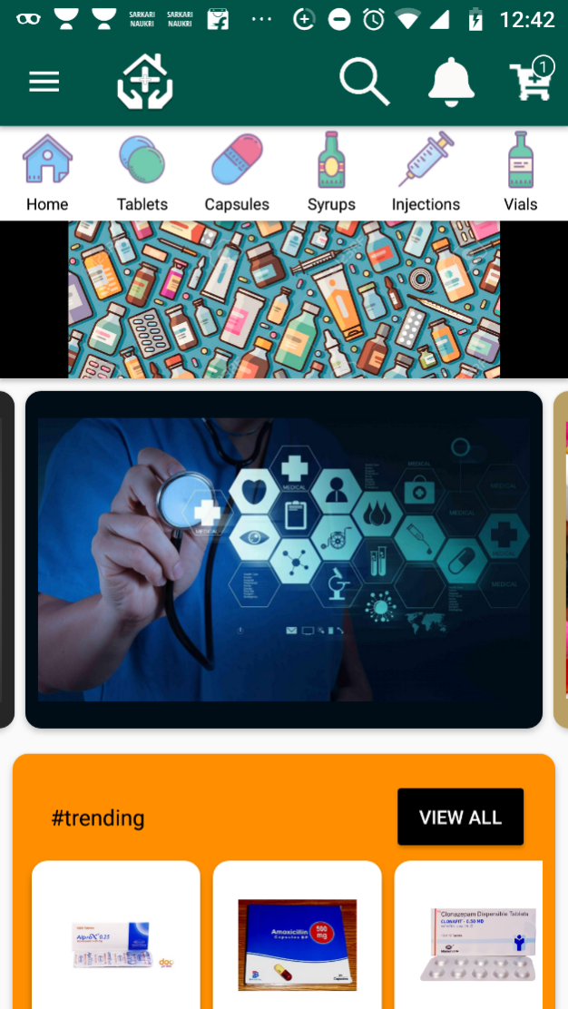

Fig 4.4.1.2 : Banner Slider Layout

**4.4.1.3 Sliding Model Layout**

This layout is shown to the user, to show them the medicines which are frequently getting purchased, which have a great discounts. The user can slide through the items in this layout to traverse inside the layout. The items can be slidden up to 8 items, and if the layout have been assigned with more than 8 items, then a view all button is enabled at the top right corner of the layout which can be clicked to view all the items assigned to the layout from the database.

Each item of the layout is clickable, so the user can click an item to go to main page of the item, on which he can find almost every detail related to the respective product and can buy the product.

The heading of the layout, number of items, item details and background colour of the layout, everything is assigned from our database, so handling this layout is very easy through the database.

Click

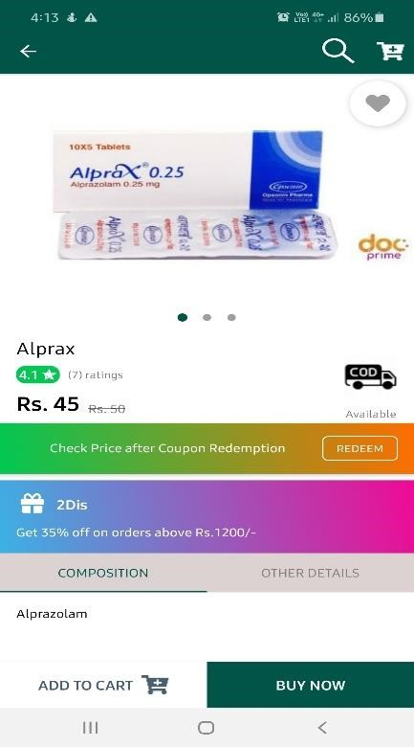

Fig 4.4.1.3: Working of Sliding Model Layout

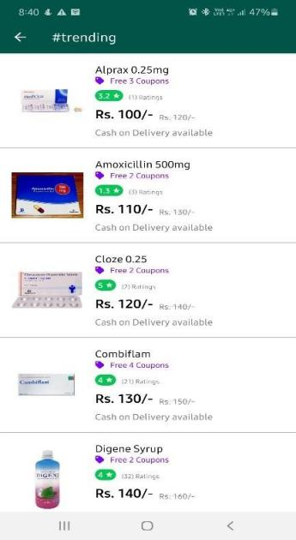

**4.4.1.4 Grid Product Layout**

This layout is created for showing the user, medicines which he can get in lesser prices. This layout will show four products in a grid at the home screen. The user can also click on the view all button to view the remaining products assigned to the same layout. The view all button will only be enabled if the layout is assigned with more than 4 products.

Each item of the grid products layout is clickable and can be clicked to get more details of the product and buy it.

Click

Fig 4.4.1.4: Working of Grid Product Layout

=vj

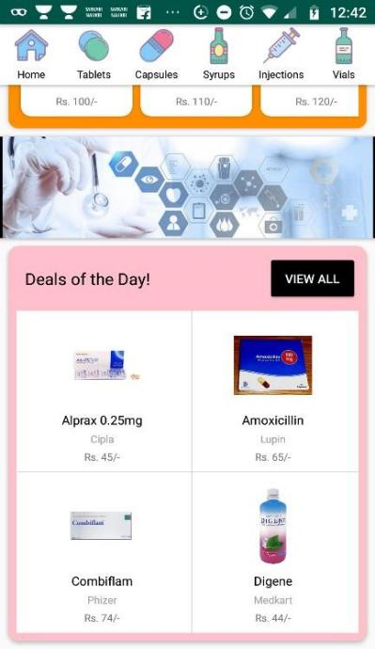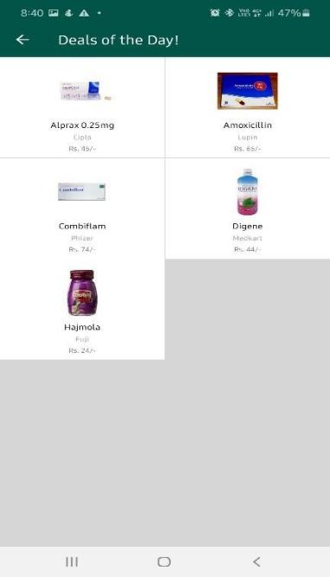

=vj

**4.4.2 My Orders**

When the user click on this option of the menu drawer then the is sent to a page where he can view his ordered items can also track their progress of delivery. The user will also have a option of rating the product from this layout. The rating of the product will also get changed in the rating sections of the product and user rating will also be saved, so he can change the rating in the future, if needed.

Through this option, The user can get track of his ordered products and can also rate the order from this layout and can also monitor his expenses incurred in real time in medicines.

When the user clicks on My Orders n the menu drawer then he is sent to a page where ordered items are visible. The user can also click on each item to get track of the order in detail and can also see on which address he has ordered the medicine, price of the medicine, delivery price, saved amount on the order etc.

Click

For Rating the product

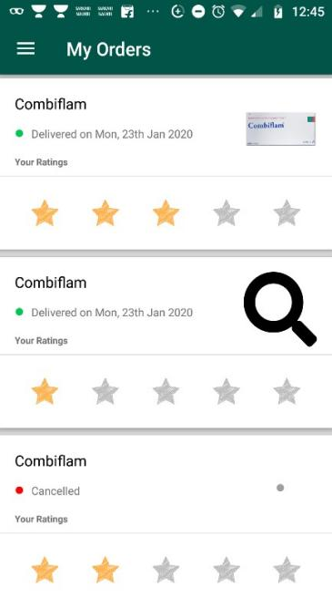

Fig 4.4.2: My Orders

**4.4.3 My Rewards**

This is the most beautiful screen of our application. This screen is completely different from all other screens of the application. The theme of this screen is very different from the main theme. This screen has a navigation bar at the top coloured in purple and content written in white below which has a gradient background. This screen gives pleasure to customer’s eyes.

Apart from the pleasure obtained from this layout, this layout shows customer the rewards which he has earned after purchases from us. This gives the customers chance to earn reward points by shopping with us. This screen has a list of the rewards earned by the user. Each item in the list has reward name, reward description and expiry date of the rewards which will help in increasing our overall sales indirectly as the user will be eager to purchase through our app as we will offer rewards after each purchase which he can use in next purchases.

This feature of our application will help to:

* Increase Brand Value
* Builds Trust
* A Stronger Connection
* Increase profit
* Competitively Edge
* Communicate Better to the customers

Click

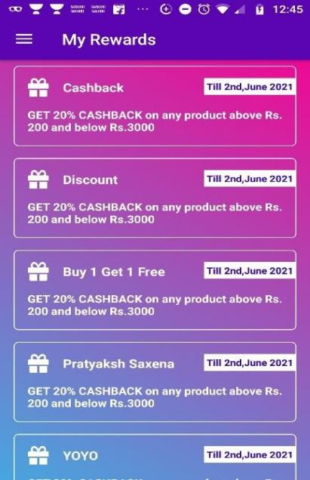

Fig 4.4.3 : My Rewards

**4.4.4: My Cart**

Cart is a very useful feature in an ecommerce application. This feature enables the customer to purchase number of products in a single order. This feature will also help the customer to increase cart price to obtain free delivery on the orders (As we are offering free delivery on purchase of more than 500/- INR).

On this screen there will be list of items which will be added by customer through “Add to Cart” button in the Product details Activity(Discussed after few pages).

On this page, the user can adjust quantity of items for purchase, can apply coupons from here, can view coupons free with the order and also can remove the item from the cart. On Cart Screen, items added, total amount of the purchase will be shown.

The user can click the Continue button at bottom-right of this screen to proceed with the order.

Click

Describing the elements

Billing Amount

Product details, free coupons etc.

Continue with the purchase

Remove item from cart

Redeem coupon for getting

better prices for the purchase

Changing Quantity of the product

Fig 4.4.4: My Cart

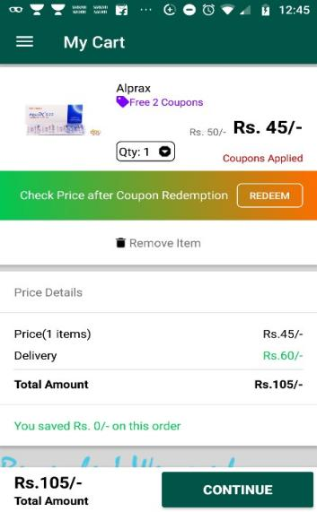

**4.4.5: My Wishlist**

This feature will be used by the customer for saving the product for future purchases or the product which he buys frequently, so he will save time by not searching the same product again and again. Each item in the wishlist is clickable. User can click the item and can go the product details page of the product. The user can also delete the irrelevant items from his wishlist by delete button at right of each item in the wishlist. The user will also be provided with the details such as availability of cash on delivery, rating on the product , free coupons, maximum retail price and price we are offering on this page.



Click

Product gets added

in the wishlist

Delete item from wishlist

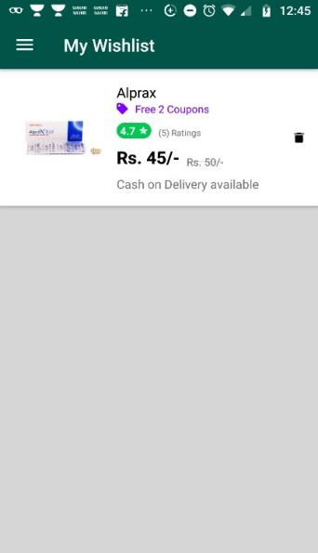

Fig 4.4.5 My Wishlist

**4.4.6: My Account**

On clicking on this button of the menu drawer, the user can see his account details, edit his account details, current order status, his recent orders, his addresses and a sign out button at the bottom.

Account page of our application does many things:

* Shows account information such as email, full name, profile picture
* Help the user to edit the account details from the settings button
* Shows status of current order
* Shows details of recent orders
* Shows saved addresses of the user
* Give user option of editing saved addresses
* Sign out the user by clicking the sign out button

View Only

Click

For adding a

new address

Edit or delete

Current address

Scroll down

Status of recent orders

View current addresses

Status of current order

For Editing account details

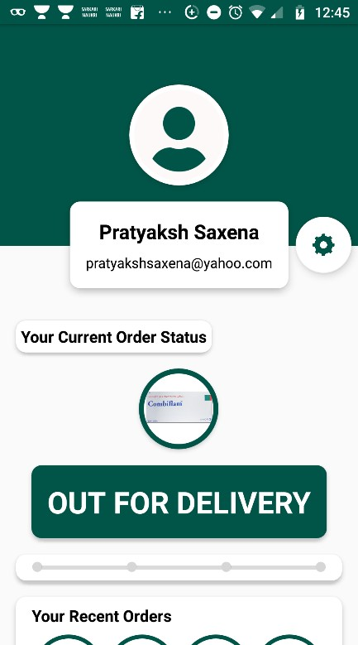

Fig: 4.4.6: My Account

**4.4.7: Sign out**



Fig 4.4.7 Sign out

This is the last option in the menu drawer. After pressing on this option, the user can sign himself out of the application. He will be transferred to the login page of the application from where he can login again.

**4.5 Product Details Activity**

This screen is created for each product in the database. When the user searches for any product or click on item of grid product layout, sliding model layout or wishlist item,

Then this screen is visible for the respective product.

View Only

Click

For Adding the product to cart

For Buying the product

For user rating

Rating details of the product

Other Details of medicine

Composition of the medicine

Product Details

Product Images. This can be

slidden to view more images

of the product

Scroll down

Scroll down

Cash on Delivery indicator

{Will only be visible when

Cash on delivery is available on the item

Add to wishlist button

Fig: 4.5: Product Details Activity

This screen shows full details of the product. It contains images of the product, product’s name, ratings on the product, product’s price, whether cash-on-delivery is available on the product, composition of the medicine, other details of the medicine. In case of a surgical item, only details is shown.

This layout has a wishlist button above the product image, which can be clicked to add the product to wishlist. It also has coupon redeem layout in it which can be clicked to apply coupon for getting discount. It also has, add to cart and buy now button at the bottom so user can click on those to add the item to cart or buy the item.

**4.6 Ordering the product**

Click

Change Quantity of the product

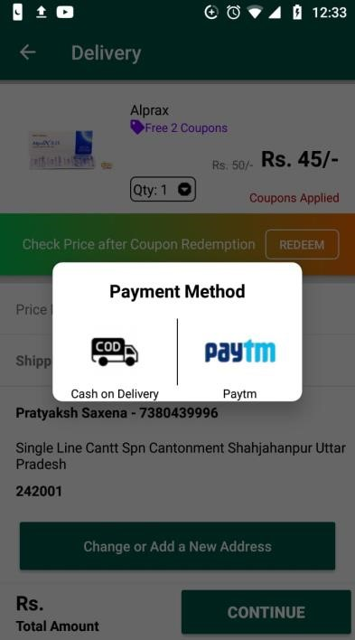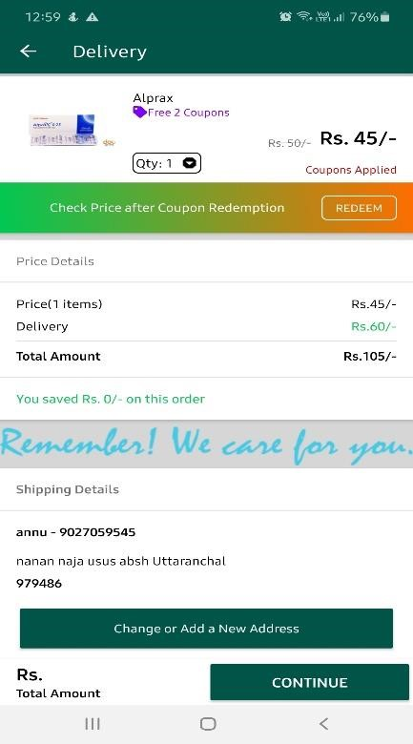

Fig: 4.6 Ordering the product

Change or Add

a new address

**4.6.1 Ordering the product through Cash on Delivery method**

View Only

Click

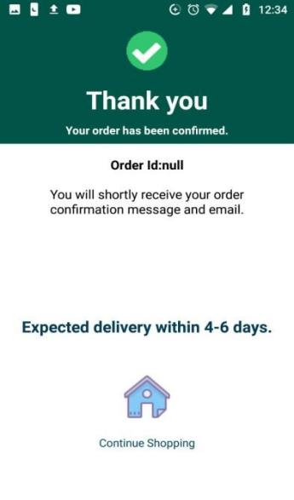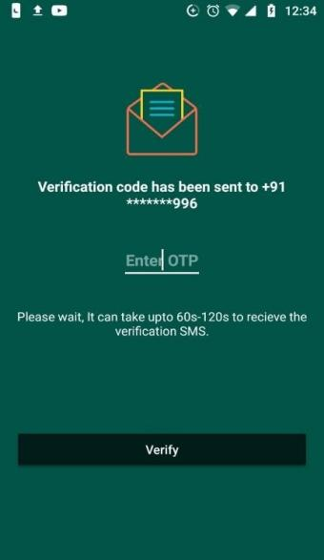

Enter OTP

And then Click

Verify

Click to go to home screen

In Application



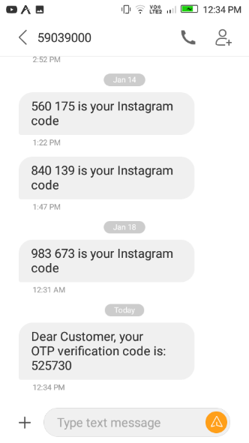

OTP received on phone

Fig: 4.6.1: Ordering the product through Cash-on-delivery

If the user feels unsafe to pay online then he can pay through COD (Cash On Delivery) Method. It will build trust in the mind of user and will also save our transaction fees of payment gateway.

In this activity, When the user clicks on COD icon in the payment dialog box, an OTP gets sent to his mobile number (one which was saved in the addresses, so it is very important to include real mobile number in the address) for confirmation of his mobile number. He needs to enter that OTP in the edit text of the screen then click on verify button, if the provided text will be same as the OTP, then his order will get confirmed and a confirmation message will be sent to the customer. If the provided text is not same as the OTP, the customer will receive an error. This will help in reducing fake orders.

After confirmation of the order, the user can click on Continue Shopping button to go to the home screen of the application.

**4.7 Add or Change address of the user**

The user can save his addresses in our application so, he won’t have to enter his address again in each order. This makes shopping very easy for the customer. The user can also add multiple addresses in our application so, he can order anywhere he is available.

The user can change or add the address in two ways, but editing and removal of address can be done in only one way:

* **Add or Change Address:**  It can either happen by editing the same in my account or in the delivery activity.
* 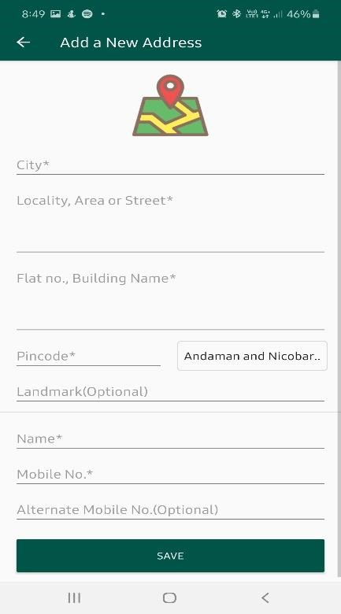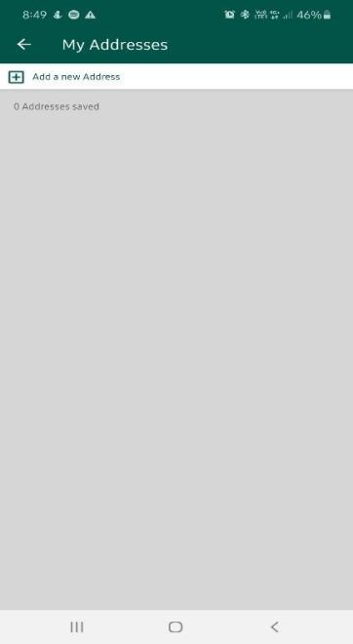‘’**Edit or Removal of Address:**  This can only be done in My Account option in the menu drawer.

Click

Enter the above

mentioned details

and

click on save button

Fig 4.7.1 Adding and removing address from delivery activity



Enter the above

mentioned details

and

click on save button

Click here to edit the address

Click here to remove the address

Click

Fig: 4.7.2: Adding, changing, removing and editing the addresses in My Account

**4.8 Scraping the data from the web**

**Data Scraping**: Data scraping, also known as web scraping, is the process of importing information from a website into a spreadsheet or local file saved on your computer. It’s one of the most efficient ways to get data from the web, and in some cases to channel that data to another website. Popular uses of data scraping include:

* Research for web content/business intelligence
* Pricing for travel booker sites/price comparison sites
* Finding sales leads/conducting market research by crawling public data sources (e.g. Yell and Twitter).
* Sending product data from an e-commerce site to another online vendor (e.g. Google Shopping)

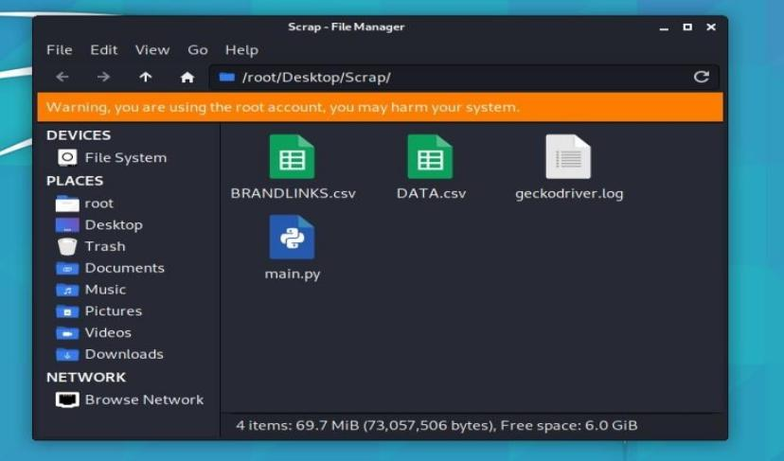

Fig 4.8.1: Explaining our Data Scraping Method

We are using Python3 for accessing web data and scraping it in a csv file. In BRANDLINKS.csv, we have our links from which data is to be scrapped. The links in BRANDLINKS.csv are also scrapped by using other links which are scrapped by another links from a website. We are explaining here final scraping of data as starting from the beginning will be very complicated to be presented in a report.

The target website has enabled robot blockers on the website, and also was using Java Script for outputs, so we have to use selenium in python for scraping and proxy-chaining in Kali Linux for changing our IP Addresses in each requests.

For Changing our IP on each requests we have applied loop in kali linux and restarted tor service on each requests which ultimately assigns us a new IP Address on each request.

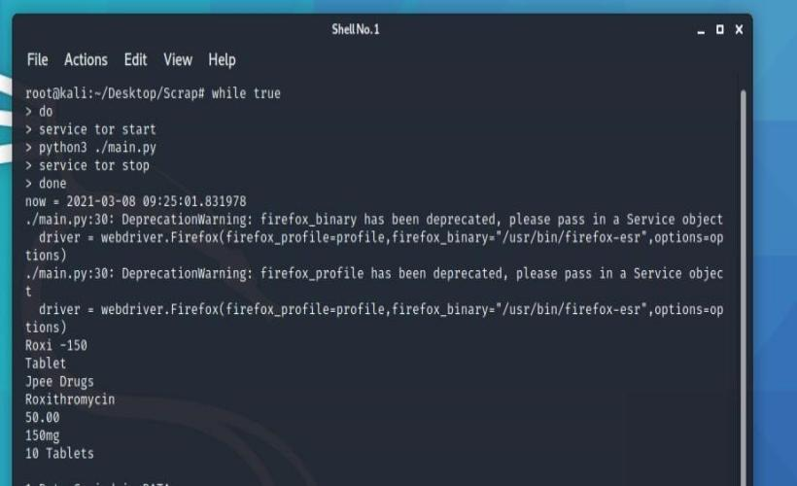

Fig 4.8.3: Query we are running in the terminal

The data after being scrapped gets appended in DATA.csv file which is storing our final data.

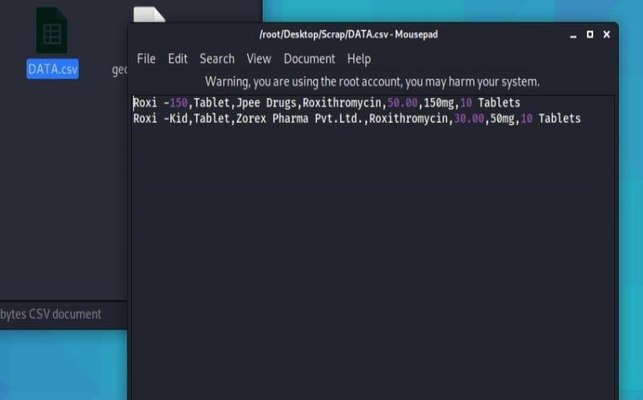

Fig 4.8.4: DATA.csv

# Chapter – 5 CONCLUSION

Online pharmacies benefit the consumer health care experience in many ways. These pharmacies provide ease of use and efficiency — two benefits for people living a busy life. Buyers can take a few minutes off their vacation to place an order, or they can order orders at any time, long after most pharmacies are open. Internet pharmacies can offer some degree of privacy that is not available at a local pharmacy, and patients can receive instructions and ask questions away from the keen eyes and listening ears of neighbours, colleagues, and other groups. Finally, Internet pharmacies help home-based patients and those living away from traditional pharmacies. Internet pharmacists engage in illegal shipping practices, however, they pose a potential risk to potential consumer health. Pharmacies that provide prescription drugs without a valid prescription or provide a prescription on the basis of an online questionnaire enable consumers to bypass the most important protection - face-to-face consultation with a licensed physician. If the patient is not examined by a doctor and passes a consultation with an official pharmacy, find the discomfort with prescription drugs and possible drug interactions, and learn about side effects. It is clear that patients should be protected from such harmful practices. The regulation, however, must not only illegally eradicate Internet pharmacies, but must also provide for the growth and development of important health care and commercial products — the official Internet pharmacy. Finally, consumer interests in online pharmacies should encourage self-expression in the medical community. Doctors and pharmacists should ask themselves why their patients prefer treatment without a doctor's prescription, face-to-face consultation, or a visit to a local pharmacy, and what legal and legal methods the medical community can use in online pharmacies to improve doctor-pharmacist-patient relationships.

**BIBLIOGRAPHY AND REFERENCES**

# Bibliography

* Stolberg SG. Official Struggle to Regulate On-Line Sale of Prescription Drugs, N.Y. Times, Jul. 31,1999.
* Mills D. Cybermedicine: The Benefits and Risks of Purchasing Drugs Over the Internet,

5.2 J. T ECH. L.& POL'Y 1, (2000).

* Mills D. Cybermedicine: The Benefits and Risks of Purchasing Drugs Over The Internet, 5.2 J. T ECH. L.& POL'Y 1, (2000).
* Bloom BS, Iannacone R. Internet availability of prescription pharmaceuticals to the public. Ann Intern Med. 1999;131:830-833.
* Rice B. Online prescribing: the growing problem of online pharmacies. Med Econ.

2001;78:40, 42, 45.

**References**:

* [https://www.google.co.in](https://www.google.co.in/)
* <http://www.wikipedia.org/>